**AdjKM.CIF: An R package for estimating the covariate-adjusted Kaplan-Meier and cumulative incidence functions**

Biwei Cao1 and Jongphil Kim1, 2*

1Department of Biostatistics and Bioinformatics, H. Lee Moffitt Cancer Center & Research Institute, Tampa, FL, USA

2Department of Oncologic Sciences, University of South Florida, Tampa, FL, USA

**\*Corresponding author**:

Jongphil Kim, PhD

H. Lee Moffitt Cancer Center & Research Institute

12902 Magnolia Drive, MRC-Bio2, Tampa, FL 33612

Phone: 813-745-6908; Fax: 813-745-6107

Email: [Jongphil.Kim@moffitt.org](mailto:Jongphil.Kim@moffitt.org)

**Introduction**

Summary plots of time-to-event outcomes in the presence or absence of competing risks are essential for oncologic studies. However, in retrospective and prospective observational studies, the groups being compared may be imbalanced regarding the prognostic factors that are significantly associated with the time-to-event outcomes. In these cases, the unadjusted Kaplan-Meier (KM) functions1 and cumulative incidence functions (CIFs) may be incompatible with the multivariable Cox proportional hazards (PH) regression model2 and the multivariable Fine-Gray subdistribution hazard regression model3. To address these concerns, the covariate-adjusted KM functions and CIFs can be estimated by the Cox and the Fine-Gray regression models, depending on the presence of the competing risks.

Several methodologies have been developed to estimate the covariate-adjusted KM functions. Suppose that is a vector of covariates in the multivariable model. The most straightforward approach is the Average Covariate method. For instance, if the outcome variable is the time-to-event endpoint in the absence of competing risks and the Cox PH model is used to build the multivariable model, the covariate-adjusted KM function, , can be computed by using an average value of covariate, ,

where is the Breslow estimate of the nonparametric baseline survival function4, and is the estimate of covariate effects obtained from the Cox PH model. Here are two key shortcomings that Nieto and Coresh5 pointed out. Firstly, suppose that a covariate, , is a binary variable and 20% is severe (coded as 1), and 80% is the mild or moderate condition (coded as 0). Then the average value of 0.2 is meaningless at the individual level. Secondly, is not necessarily the same as the average survival estimate from a heterogeneous group of subjects. Due to these flaws, the Direct Adjustment method was proposed by Chang et al.6 and Makuch7 to estimate the covariate-adjusted KM function by using a weighted average of the individual KM functions, with weights proportional to the number of subjects at each level of covariates in the entire population

.

This approach is appropriate if the PH assumption is valid. Note that as the common baseline survival function is used, there is no difference in “event time points” between groups, and the number of events does not match the actual number of events in each group. If the PH assumption is invalid or if practitioners need a method by which the event time points of the adjusted function match those of the unadjusted function, the stratified Cox model can be selected as an alternative (Gail and Byar8 and Storer et al.9).

Xie and Liu10 developed a method for the adjusted KM estimator using Inverse Probability of Treatment Weighting that can be implemented by an R function “ipw.survival”. A SAS macro, “%ADJSURV”, for the direct covariate-adjusted survival functions by the stratified Cox model has been developed by Zhang et al.11. Rosthøj et al.12 developed SAS macros, “%CumInc” and “%CumIncV”, to produce CIFs based upon the cause-specific hazard approach of the Cox regression model. Klein et al.13 published the SAS macros and R functions to compute the pseudo-values of the restricted mean survival functions and CIFs using the standard generalized estimating equation. Zhang and Zhang14 developed two SAS macros, “%CIFCOX” and “%CIFSTRATA”, to create the direct adjusted CIFs based upon the Fine-Gray regression model and the stratified Fine-Gray regression model, respectively. Kohl et al.15 developed a SAS macro “%pshreg” that can be used to fit a proportional subdistribution hazards model for survival data in the presence of competing risks. A SAS macro “%adjsurvlt” was recently published by Hu et al.16, 17 to produce the direct survival functions for the left-truncated and right-censored data. A function, “ggcoxadjustedcurves” in the R package “survminer”, provides the covariate-adjusted survival functions based on the Cox PH regression model.

To our knowledge, neither R package nor R shiny application is available for estimating the stratified Cox model-based, covariate-adjusted KM functions and the covariate-adjusted CIFs based upon the (stratified) Fine-Gray subdistribution hazard regression model. Furthermore, the Storer method is unavailable in the SAS macros and the R packages. Therefore, we offer not only the Gail and Byar method but also the Storer method for the users of the stratified Cox model and the stratified Fine-Gray regression model. Besides, we seek to provide the confidence intervals by the bootstrap percentile method (Efron18).

**Example: BMT data**

The statistical methods used for our package, *AdjKM.CIF*, are presented in Appendix A. The bone marrow transplant (BMT) data from section 1.3 of the textbook by Klein and Moeschberger19 is used to illustrate the R package and the R shiny application. The “KMsurv” package can load the BMT data.

> library(KMsurv)

> data(bmt)

The BMT data consists of 137 rows (i.e., the number of subjects) and 22 columns (i.e., variables). The variable “t2” computed in days indicates the disease-free survival (DFS), defined as time to relapse, death, or last follow-up, and is converted to months as follows. The variable “d3” is the indicator of DFS (1 – death or relapse, 0 – alive disease-free), while “d2” indicates the relapse of disease (1 – relapse, 0 – non-relapse). A new variable “arm” is defined as a character variable by using the “group” variable, and level 2 (acute myeloid leukemia (AML) low-risk) of “arm” is selected as the reference group in the Cox and Fine-Gray regression models. Levels 1 and 3 indicate acute lymphocytic leukemia (ALL) and AML high-risk group, respectively. The new variable “CenCI” is created to represent the cause of events (0 – alive without disease relapse, 1 – relapse, and 2 – death without disease relapse) and will be used to estimate the CIF of each event. Table 1 shows the first 10 subjects of the BMT data.

> bmt$arm <- bmt$group

> bmt$arm <- factor(as.character(bmt$arm), levels = c("2", "1", "3"))

> bmt$t2 <- bmt$t2 * 12 /365.25

> bmt$z3 <- as.character(bmt$z3)

> bmt$CenCI <- 0

> for(ii in 1:137) {

+ if (bmt$d3[ii] == 0){

+ bmt$CenCI[ii] <- 0

+ } else {

+ if (bmt$d2[ii] == 1){

+ bmt$CenCI[ii] <- 1

+ } else {

+ bmt$CenCI[ii] <- 2

+ }

+ }

+ }

The “AdjKM.CIF” package can be installed from GitHub by using the “devtools” package and then should be loaded by using the library function. We also load the “tidyverse”, “DT”, and “ggplot2” packages as they are used throughout the manuscript.

> install.packages("devtools")

> devtools::install_github("Lesly1031/AdjKM.CIF",dependencies = TRUE)

> library(AdjKM.CIF)

> library(tidyverse)

> library(DT)

> library(ggplot2)

**Covariate-Adjusted KM functions**

The function “adjusted_KM (data, time, status, group, covlist, stratified_cox, reference_group)” in the package computes the covariate-adjusted KM functions. The function arguments are as follows.

* data: the input dataset
* time: column names of time variable
* status: column names of event status, 0 is the censored and 1 is the event
* group: group variable being compared
* covlist: list of covariates included in the Cox model
* stratified_cox
  + “No”: Cox proportional hazard regression model
  + “Yes”: Stratified Cox regression model
* reference_group
  + “NULL”: No reference group required for the Cox PH model
  + “G&B”: the Gail and Byar method
  + “group:level”: the reference group for the Storer method (e.g., “arm:2” in the BMT data)

The function “adjKM_plot(res, data)” generates the covariate-adjusted KM function based on the results obtained from the function “adjusted_KM()”. Two arguments are

* res: the result of adjusted_KM() function,
* data: input dataset.

**Cox proportional hazards regression model**

Suppose that the multivariable Cox PH model for DFS includes the risk group (“arm”), age (“z1”), and gender (“z3”), regardless of statistical significance. Then the age and gender-adjusted KM functions can be calculated by the Cox PH regression model. Gender is defined as a binary variable by the “as.character” function. The function “spread()” generates the data frame showing the survival rate at each time point by the study group. Panel A of Figure 1 shows the age and gender-adjusted KM functions based on the Cox PH model. As each KM function shares the baseline survival function , the distance between KM functions reflects the hazard ratios under the PH assumption (i.e., the hazard ratio of level 1 to level 2 is 1.95, and the ratio of level 3 to level 2 is 2.57 after adjusting age and gender). The labels and ticks can be handled by the “ggplot()” as shown below.

> result1 <- adjusted_KM(data = bmt, time = "t2", status = "d3", group = "arm",

+ covlist = c("z1", "z3"), stratified_cox = "No", reference_group = NULL)

> table_res1 <- spread(result1, class, prob)

> adjKM_plot(result1, data = bmt)

> ggplot(result1,aes(x = time, y = prob, group = class))+

+ geom_step(aes(linetype = class, color = class),size = 1.5)+

+ theme_classic() + ylim(c(0,1)) +

+ scale_x_continuous(name = "Time (Months)",breaks = seq(0, 84, 12))+

+ ylab("Probability")

**Stratified Cox model**

The stratified Cox regression model can be applied if the argument “stratified_cox = "Yes"” is selected, where the group variable serves as the stratification variable in the model. The reference group () per the Gail and Byar method includes all subjects in each group by specifying “reference_group = "G&B"” while the Storer method selects a specific group (in this example, level 2 of arm) as the reference group by “reference_group = "arm:2””. Panel B and C of Figure 1 depict the age and gender-adjusted KM functions by the Gail and Byar method and the Storer method, respectively.

> result2 <- adjusted_KM(data = bmt, time = "t2", status = "d3", group = "arm",

+ covlist = c("z1","z3"), stratified_cox = "Yes", reference_group = "G&B")

> adjKM_plot(result2, data = bmt)

> result3 <- adjusted_KM(data = bmt, time = "t2", status = "d3", group = "arm",

+ covlist = c("z1","z3"), stratified_cox = "Yes", reference_group = "arm:2")

> adjKM_plot(result3, data = bmt)

**Confidence intervals by the bootstrap percentile method**

The function “boot_ci_adj_km(boot_n, ci_cut, data, time, status, group, covlist, stratified_cox, reference_group)” computes the covariate-adjusted KM functions along with confidence intervals by the bootstrap percentile method. Two additional arguments are required:

* boot_n: the bootstrap sample size,
* ci_cut: default c(0.025, 0.975), the lower and upper limit of 95% bootstrap confidence intervals

The function “adjKM_CI_plot(res, data)” generates the covariate-adjusted KM functions based on the results obtained from the function “boot_ci_adj_km()”. Two arguments used in the function are

* res: the result of the function boot_ci_adj_km(),
* data: input dataset

The age and gender-adjusted KM functions and 95% pointwise confidence intervals by the bootstrap percentile method are computed. Here, 1000 bootstrap samples are generated, and the 2.5 and 97.5 percentiles at each time point are chosen as the lower and upper limits of the 95% confidence intervals. Panel D of Figure 1 depicts the bootstrap KM functions with 95% confidence intervals based upon the Cox PH model. The function “do.call” creates the data frame based on the results of the function “boot_ci_adj_km()”. With this data frame, the function “ggplot()” can handle the labels and ticks of the plot. In addition, the Gail and Byar method and the Storer method can be applied if the stratified_cox = “Yes” and reference_group = “G&B” or a specific level of the group variable (e.g., “arm:2”) are chosen.

> result4 <- boot_ci_adj_km(boot_n=1000, ci_cut = c(0.025, 0.975), data = bmt, time = "t2",

+ status = "d3", group = "arm", covlist = c("z1", "z3"), stratified_cox = "No",

+ reference_group = NULL)

> adjKM_CI_plot(result4, dt)

> result4_1 <- do.call(rbind, result4)

> ggplot(data.frame(result4_1), aes(x = time, y = t_sub_mean, group = class)) +

+ geom_step(aes(linetype = class, color = class), size = 1.2) +

+ geom_ribbon(aes(ymin = lower, ymax = upper, fill = class),alpha = 0.3) +

+ ylim(c(0, 1)) + theme_classic() +

+ scale_x_continuous(name = "Time (Months)",breaks = seq(0, 84, 12)) +

+ ylab("Probability")

**Covariate-Adjusted cumulative incidence functions (CIFs)**

The function “adjusted_CIF(data, time, status, group, covlist, event_code, stratified, reference_group)” computes the covariate-adjusted CIF. When compared with the function “adjusted_KM”, one additional argument is needed

* event_code: the event of interest, (in the BMT data, 1 – relapse and 2 – non-relapse mortality).

The function “adjCIF_plot(res, data)” generates the covariate-adjusted CIF based upon the results from the function “adjusted_CIF()”. Two arguments of the function are

* res: the result of adjusted_CIF() function,
* data: input dataset

**Fine-Gray subdistribution hazard regression model**

Suppose that the relapse is of interest. The age and gender-adjusted CIFs of relapse (event code = 1) can be estimated by the Fine-Gray regression model. Panel A of Figure 2 shows the age and gender-adjusted CIFs. As the adjusted CIFs are estimated by using the common baseline CIF of relapse, the distance between the CIFs is proportional to the hazard ratios between groups (i.e., the hazard ratio of level 1 to level 2 is 2.41, and the ratio of level 3 to level 2 is 3.73 after adjusting for age and gender).

> result1 <- adjusted_CIF(data = bmt, time = "t2", status = "CenCI", group = "arm",

+ covlist = c("z1", "z3"), event_code = 1, stratified = "No", reference_group = NULL)

> table_res1 <- spread(result1, class, prob)

> adjCIF_plot(result1, bmt)

> ggplot(result1, aes(x = time, y = prob, group = class)) +

+ geom_step(aes(linetype = class,color = class), size = 1.5) +

+ theme_classic() + ylim(c(0, 1)) +

+ scale_x_continuous(name = "Time (Months)",breaks = seq(0, 84, 12))+

+ ylab("Probability")

**Stratified Fine-Gray model**

As in the stratified Cox model, the stratified Fine-Gray model can be employed if the argument “stratified = “Yes”” is selected. Contrary to what is described in the R package “crrSC” developed by Zhou et al.20, the stratified baseline cumulative subdistribution hazard function is not available by the package. Thus, a function is built in our package “AdjKM.CIF” to estimate the stratified baseline cumulative subdistribution hazard function. Panel B and C of Figure 2 depict age and gender-adjusted CIFs by the Gail and Byar method and the Storer method, respectively. Level 2 of the group variable is selected as the reference group for the Storer method.

> result2 <- adjusted_CIF(data = bmt, time = "t2", status = "CenCI", group = "arm",

+ covlist = c("z1", "z3"), event_code = 1, stratified = "Yes",

+ reference_group = "G&B")

> adjCIF_plot(result2, bmt)

> result3 <- adjusted_CIF(data = bmt, time = "t2", status = "CenCI", group = "arm",

+ covlist = c("z1", "z3"), event_code = 1, stratified = "Yes",

+ reference_group = "arm:2")

> adjCIF_plot(result3, data = bmt)

**Confidence intervals by the bootstrap percentile method**

The function “boot_ci_adj_cif(boot_n, ci_cut, data, time, status, group, covlist, event_code, stratified, reference_group)” computes the covariate-adjusted CIFs with the percentile-based bootstrap confidence intervals. Two additional arguments are needed:

* boot_n: the bootstrap sample size,
* ci_cut: default c(0.025, 0.975), the lower and upper limit of 95% bootstrap confidence intervals.

Similarly, the function “adjCIF_CI_plot(res, data)” generates the covariate-adjusted CIFs from the function “boot_ci_adj_cif()”. Two arguments used in the function are

* res: the result of boot_ci_adj_cif(),
* data: input dataset.

The age and gender-adjusted bootstrap CIFs of relapse along with 95% pointwise confidence intervals are computed by the function “boot_ci_adj_cif()”. Panel D of Figure 2 depicts the adjusted CIFs of relapse with 95% confidence intervals when the Fine-Gray regression is applied. The bootstrap sample size is 1000. The Gail and Byar method and the Storer method can be employed to compute the bootstrap confidence intervals if the stratified = "Yes" is selected and the reference group is defined. The following is an example where the Fine-Gray regression model is employed.

> result4 <- boot_ci_adj_cif(boot_n = 1000, ci_cut = c(0.025, 0.975), data = bmt,

+ time = "t2", status = "CenCI", group = "arm",

+ covlist = c("z1", "z3"), event_code = 1,

+ stratified ="No", reference_group = NULL)

> adjCIF_CI_plot(result4, dt)

> result4_1 <- do.call(rbind, result4)

> ggplot(data.frame(result4_1), aes(x = time, y = t_sub_mean, group = class)) +

+ geom_step(aes(linetype = class, color = class), size = 1.2) +

+ geom_ribbon(aes(ymin = lower, ymax = upper, fill = class),alpha = 0.3) +

+ ylim(c(0, 1)) + theme_classic() +

+ scale_x_continuous(name = "Time (Months)",breaks = seq(0, 84, 12)) +

+ ylab("Probability")

**Conclusions**

We seek to develop a novel R package, “AdjKM.CIF”, and a user-friendly R-shiny application that estimates the covariate-adjusted Kaplan-Meier (KM) functions and the cumulative incidence functions (CIFs). The R-shiny application is available at <http://AdjKM-CIF.moffitt.org/>, and the introduction is attached in Appendix B. The Cox proportional hazard (PH) regression model and the Fine-Gray subdistribution hazard regression model are appropriate if the PH assumption between the groups is valid. If the assumption is invalid or if the adjusted functions that have the same event time points of the corresponding unadjusted functions are needed, then the stratified models would be selected as an alternative since the stratified model allows the baseline hazard function to vary for each group. Two methods, the Gail and Byar method and the Storer method, are offered, depending on the selection of the reference group. The pros and cons of these methods are discussed in Storer et al.9, and thus we confine our attention to the development of the R package and R shiny application. In addition, the bootstrap percentile method is employed to estimate pointwise confidence intervals. Before applying the stratified model, users should note that the covariate effects of the Cox and Fine-Gray regression model may be different from those of the stratified model and decide whether the use of the stratified model is acceptable.

**Availability of data and material**

The R package, “AdjKM.CIF”, is available at <https://github.com/Lesly1031/AdjKM.CIF>. The “KMsurv” package can load the BMT data. The user-friendly R shiny application is available at <http://AdjKM-CIF.moffitt.org/>.

**Conflict of Interest**

All authors declare no competing interest and have no conflict of interest to disclose.

**Funding**

This work has been supported in part by the Biostatistics and Bioinformatics Shared Resource at the H. Lee Moffitt Cancer Center & Research Institute, an NCI designated Comprehensive Cancer Center (P30-CA076292).

**Authors’ Contribution**

BC and JK developed the method and are responsible for interpreting results and drafting the paper. All authors read and approved the final manuscript.

**References**

1. Kaplan EL, Meier P. Nonparametric-Estimation from Incomplete Observations. Journal of the American Statistical Association. 1958;53(282):457-81. doi: Doi 10.2307/2281868.

2. Cox DR. Regression Models and Life-Tables. Journal of the Royal Statistical Society Series B-Statistical Methodology. 1972;34(2):187-220.

3. Fine JP, Gray RJ. A proportional hazards model for the subdistribution of a competing risk. Journal of the American Statistical Association. 1999;94(446):496-509. doi: Doi 10.2307/2670170.

4. Breslow NE. Analysis of Survival Data under Proportional Hazards Model. International Statistical Review. 1975;43(1):45-58. doi: Doi 10.2307/1402659.

5. Nieto FJ, Coresh J. Adjusting survival curves for confounders: a review and a new method. Am J Epidemiol. 1996;143(10):1059-68. Epub 1996/05/15. doi: 10.1093/oxfordjournals.aje.a008670. PubMed PMID: 8629613.

6. Chang IM, Gelman R, Pagano M. Corrected Group Prognostic Curves and Summary Statistics. Journal of Chronic Diseases. 1982;35(8):669-74. doi: Doi 10.1016/0021-9681(82)90019-4.

7. Makuch RW. Adjusted Survival-Curve Estimation Using Covariates. Journal of Chronic Diseases. 1982;35(6):437-43. doi: Doi 10.1016/0021-9681(82)90058-3.

8. Gail MH, Byar DP. Variance Calculations for Direct Adjusted Survival Curves, with Applications to Testing for No Treatment Effect. Biometrical Journal. 1986;28(5):587-99. doi: DOI 10.1002/bimj.4710280508.

9. Storer BE, Gooley TA, Jones MP. Adjusted estimates for time-to-event endpoints. Lifetime Data Analysis. 2008;14(4):484-95. doi: 10.1007/s10985-008-9098-9.

10. Xie J, Liu CF. Adjusted Kaplan-Meier estimator and log-rank test with inverse probability of treatment weighting for survival data. Stat Med. 2005;24(20):3089-110. doi: 10.1002/sim.2174.

11. Zhang X, Loberiza FR, Klein JP, Zhang MJ. A SAS macro for estimation of direct adjusted survival curves based on a stratified Cox regression model. Computer Methods and Programs in Biomedicine. 2007;88(2):95-101. doi: 10.1016/j.cmpb.2007.07.010.

12. Rosthoj S, Andersen PK, Abildstrom SZ. SAS macros for estimation of the cumulative incidence functions based on a Cox regression model for competing risks survival data. Comput Methods Programs Biomed. 2004;74(1):69-75. Epub 2004/03/03. doi: 10.1016/S0169-2607(03)00069-5. PubMed PMID: 14992828.

13. Klein JP, Gerster M, Andersen PK, Tarima S, Perme MP. SAS and R functions to compute pseudo-values for censored data regression. Comput Methods Programs Biomed. 2008;89(3):289-300. Epub 2008/01/18. doi: 10.1016/j.cmpb.2007.11.017. PubMed PMID: 18199521; PMCID: PMC2533132.

14. Zhang X, Zhang MJ. SAS macros for estimation of direct adjusted cumulative incidence curves under proportional subdistribution hazards models. Comput Methods Programs Biomed. 2011;101(1):87-93. Epub 2010/08/21. doi: 10.1016/j.cmpb.2010.07.005. PubMed PMID: 20724020; PMCID: PMC3377442.

15. Kohl M, Plischke M, Leffondre K, Heinze G. PSHREG: a SAS macro for proportional and nonproportional subdistribution hazards regression. Comput Methods Programs Biomed. 2015;118(2):218-33. Epub 2015/01/13. doi: 10.1016/j.cmpb.2014.11.009. PubMed PMID: 25572709; PMCID: PMC4673318.

16. Hu ZH, Wang HL, Gale RP, Zhang MJ. Correction to: A SAS macro for estimating direct adjusted survival functions for time-to-event data with or without left truncation. Bone Marrow Transplant. 2022. Epub 2022/02/03. doi: 10.1038/s41409-021-01533-1. PubMed PMID: 35105967.

17. Hu ZH, Wang HL, Gale RP, Zhang MJ. A SAS macro for estimating direct adjusted survival functions for time-to-event data with or without left truncation. Bone Marrow Transplant. 2022;57(1):6-10. Epub 2021/08/21. doi: 10.1038/s41409-021-01435-2. PubMed PMID: 34413470.

18. Efron B. Censored Data and the Bootstrap. Journal of the American Statistical Association. 1981;76(374):312-9. doi: Doi 10.2307/2287832.

19. Klein JP, Moeschberger ML. Survival Analysis: Techniques for Censored and Truncated Data: Springer, New York, NY; 1997.

20. Zhou BQ, Latouche A, Rocha V, Fine J. Competing Risks Regression for Stratified Data. Biometrics. 2011;67(2):661-70. doi: 10.1111/j.1541-0420.2010.01493.x.

21. Putter H, Schumacher M, van Houwelingen HC. On the relation between the cause-specific hazard and the subdistribution rate for competing risks data: The Fine-Gray model revisited. Biometrical Journal. 2020;62(3):790-807. doi: 10.1002/bimj.201800274.

Figure 1. The age and gender-adjusted KM functions by the Cox proportional hazards regression model (panel A), the Gail and Byar method (panel B), and the Storer method (panel C) based upon the stratified Cox model. Panel D shows the age and gender-adjusted KM functions with the 95% confidence intervals by the bootstrap percentile method (bootstrap sample size = 1000).

Figure 2. The age and gender-adjusted CIFs by the Fine-Gray regression model (panel A), the Gail and Byar method (panel B), and the Storer method (panel C) based upon the stratified Fine-Gray regression model. Panel D shows age and gender-adjusted CIFs with the 95% confidence intervals by the bootstrap percentile method (bootstrap sample size = 1000).

Table 1. The first 10 subjects in BMT Data

|  |  |  |  |  |  |  |  |  |  |  |  |  |  |  |  |  |  |  |  |  |  |  |  |
| --- | --- | --- | --- | --- | --- | --- | --- | --- | --- | --- | --- | --- | --- | --- | --- | --- | --- | --- | --- | --- | --- | --- | --- |
| **group** | **t1** | **t2** | **d1** | **d2** | **d3** | **ta** | **da** | **tc** | **dc** | **tp** | **dp** | **z1** | **z2** | **z3** | **z4** | **z5** | **z6** | **z7** | **z8** | **z9** | **z10** | **arm** | **CenCI** |
| 1 | 2081 | 68.4156886 | 0 | 0 | 0 | 67 | 1 | 121 | 1 | 13 | 1 | 26 | 33 | 1 | 0 | 1 | 1 | 98 | 0 | 1 | 0 | 1 | 0 |
| 1 | 1602 | 52.667916 | 0 | 0 | 0 | 1602 | 0 | 139 | 1 | 18 | 1 | 21 | 37 | 1 | 1 | 0 | 0 | 1720 | 0 | 1 | 0 | 1 | 0 |
| 1 | 1496 | 49.1830227 | 0 | 0 | 0 | 1496 | 0 | 307 | 1 | 12 | 1 | 26 | 35 | 1 | 1 | 1 | 0 | 127 | 0 | 1 | 0 | 1 | 0 |
| 1 | 1462 | 48.0652267 | 0 | 0 | 0 | 70 | 1 | 95 | 1 | 13 | 1 | 17 | 21 | 0 | 1 | 0 | 0 | 168 | 0 | 1 | 0 | 1 | 0 |
| 1 | 1433 | 47.1118125 | 0 | 0 | 0 | 1433 | 0 | 236 | 1 | 12 | 1 | 32 | 36 | 1 | 1 | 1 | 1 | 93 | 0 | 1 | 0 | 1 | 0 |
| 1 | 1377 | 45.2707368 | 0 | 0 | 0 | 1377 | 0 | 123 | 1 | 12 | 1 | 22 | 31 | 1 | 1 | 1 | 1 | 2187 | 0 | 1 | 0 | 1 | 0 |
| 1 | 1330 | 43.7255482 | 0 | 0 | 0 | 1330 | 0 | 96 | 1 | 17 | 1 | 20 | 17 | 1 | 0 | 1 | 1 | 1006 | 0 | 1 | 0 | 1 | 0 |
| 1 | 996 | 32.7448466 | 0 | 0 | 0 | 72 | 1 | 121 | 1 | 12 | 1 | 22 | 24 | 1 | 0 | 0 | 0 | 1319 | 0 | 1 | 0 | 1 | 0 |
| 1 | 226 | 7.43005556 | 0 | 0 | 0 | 226 | 0 | 226 | 0 | 10 | 1 | 18 | 21 | 0 | 1 | 0 | 0 | 208 | 0 | 1 | 0 | 1 | 0 |
| 1 | 1199 | 39.4187461 | 0 | 0 | 0 | 1199 | 0 | 91 | 1 | 29 | 1 | 24 | 40 | 1 | 1 | 0 | 1 | 174 | 0 | 3 | 1 | 1 | 0 |

**Appendix A: Methods**

**Covariate-Adjusted KM functions**

Suppose that is the sample size of group and that is referred to as the set of subjects in group . The covariate-adjusted KM function for group by the Average Covariate method can be obtained by

,

where is the nonparametric baseline survival function, and is the estimate of covariate effects from the Cox PH model. This approach is appropriate if the PH assumption is valid. As the common baseline survival function is used, there is no difference in “event time points” between groups, and the number of events does not match the actual number of events in each group.

Suppose that groups are being compared. The stratified Cox model allows the baseline hazard function to vary for group . A stratified hazard function of subject within group under the PH assumption is

where is the baseline hazard function for group , is the estimate of covariate effects from the stratified Cox model, and is the vector of the covariate of subject within group at time . The estimate of the baseline survival function for group , , is

.

The event time points of the exactly match those of the corresponding unadjusted KM functions. In our R package, we assume that is time-invariant (i.e., ). Depending on the selection of the reference group, two types of the covariate-adjusted KM function for group , , can be computed by

,

where is the sample size of the reference group, is referred to as the set of subjects in the reference group, and is the covariate of subject in the reference group. The reference group () per the Gail and Byar approach includes all subjects in group while the Storer method selects a specific group as the reference group. As the reference group is used for all groups, the Storer method is more appropriate to answer the question, “What if the subject characteristic of all groups is the same as the reference group?” The pros and cons are well discussed in Storer et al.9.

**Covariate-adjusted CIF**

Suppose that there are mutually exclusive competing risks and is the cumulative incidence function of event . The subdistribution hazard function, of event is defined by Fine and Gray as

.

The detailed comparisons with the cause-specific hazard function are presented in Putter et al.21. The subdistribution hazard function, , of event for subject under the PH assumption is

,

where is the baseline subdistribution hazard function of event , and is the value of a covariate at time . The estimate of covariate-adjusted CIF, , of event for subject can be computed by

,

where and is the estimate of the baseline subdistribution hazard function and the estimate of covariate effects from the Fine-Gray regression model. If the covariate is time-invariant and is the estimate of the baseline cumulative subdistribution hazard function of event , then the covariate-adjusted CIF, , of event for subject is

,

where is the baseline CIF of event . The Direct Adjustment method can be applied to compute the covariate-adjusted CIF, , of event for group by

.

As in the stratified Cox model, the stratified Fine-Gray regression model by Zhou et al.20 allows the baseline subdistribution hazard function to vary for each group. A stratified subdistribution hazard function, , of event for subject within group under the PH assumption is

where is the baseline subdistribution hazard function of event for group , is the estimate of covariate effects from the stratified Fine-Gray regression model, and is the time-invariant covariate of subject within group . Let be the baseline CIF of event for group . Then covariate-adjusted CIF, for group is computed by

,

where is the sample size of the reference group and is the covariate of subject in the reference group (). The Gail and Byar method and the Storer method are available in our R package and shiny application.

**Appendix B: Introduction to R shiny application**

We propose a new online tool and interactive analysis portal designed to generate covariate-adjusted Kaplan Meier (KM) functions and cumulative incidence functions (CIFs). The tool fills a gap in creating the stratified Cox model-based, covariate-adjusted KM functions and (stratified) Fine-Gray model-based, covariate-adjusted CIF functions in R.

**Upload data**

The first tab is "upload dataset", enabling users to upload their datasets. The file must be in CSV format and be processed before being uploaded to the app (e.g., 0 is censored and 1 is the event, etc.). The default bone marrow transplant (BMT) dataset is from a book by Klein and Moeschberger and can be loaded by the "KMsurv" R package.

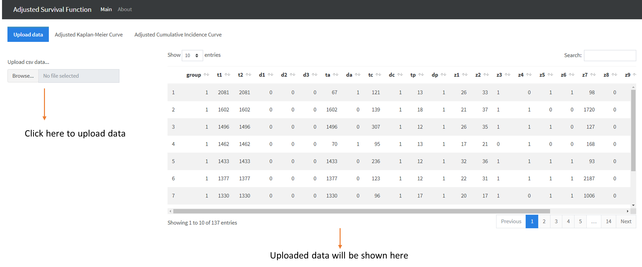

**Adjusted Kaplan-Meier Functions**

The second tab is to generate covariates-adjusted Kaplan-Meier plot. We provide unstratified Cox model-based adjusted KM and stratified Cox model-based adjusted KM. Bootstrap estimate along with 95% confidence interval (CI) can also be shown by inputting bootstrap sample size in the “Compute bootstrap CI” input box (0 – no bootstrap CI). Once the user interface part is complete, the corresponding KM plot and probability table will be shown accordingly.

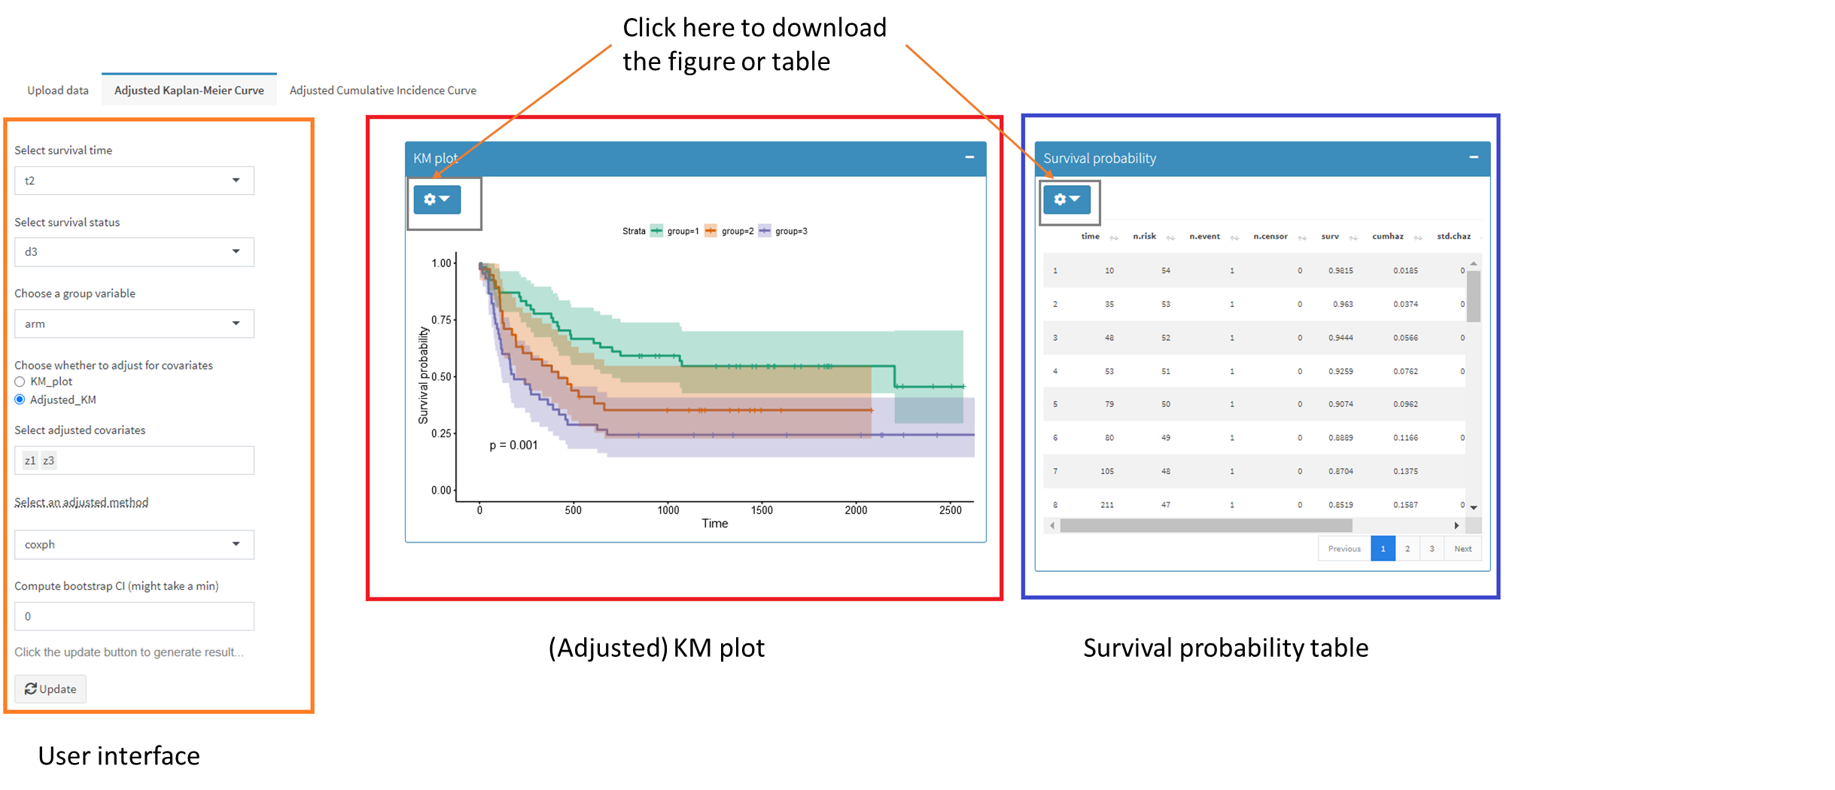

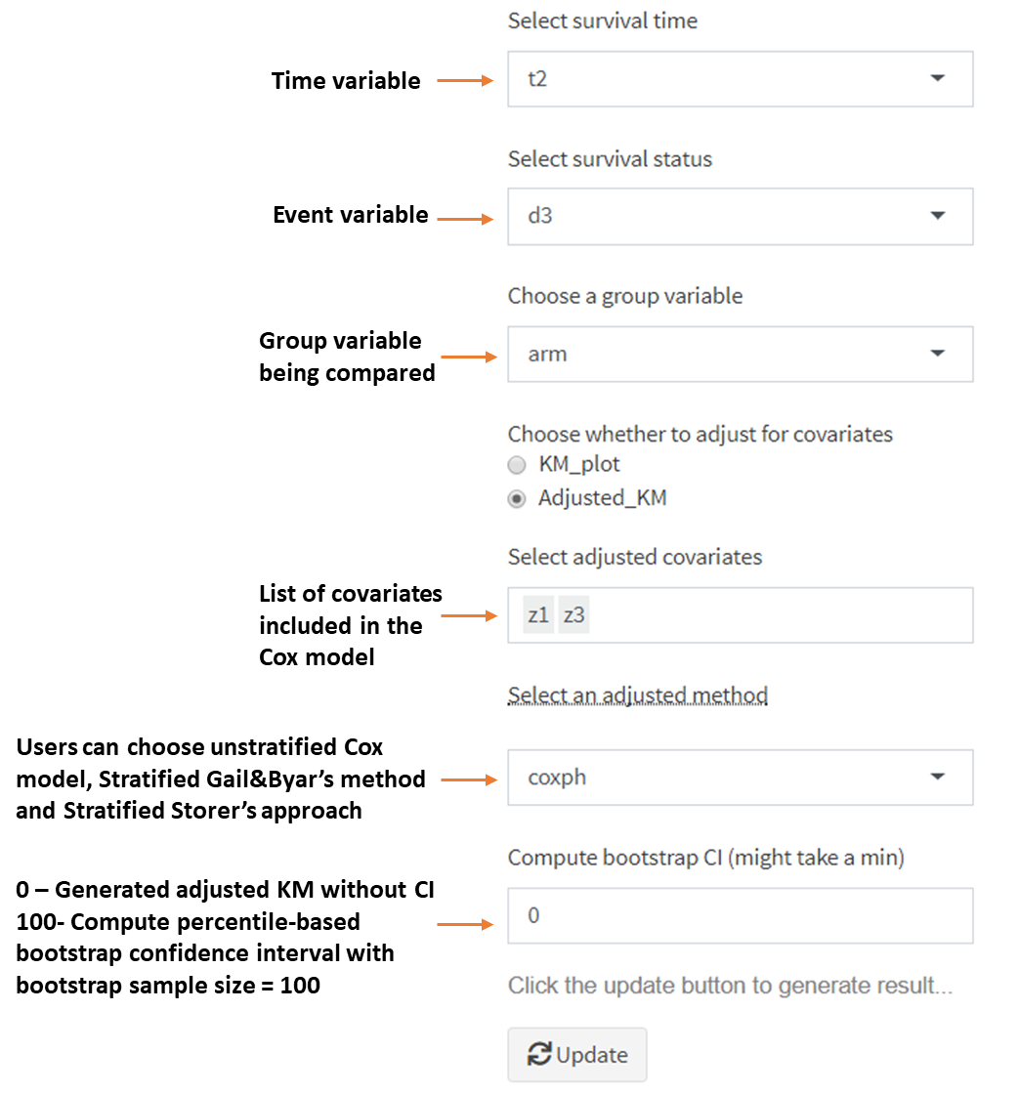

**Adjusted Cumulative Incidence Curve**

The third tab is to generate covariates-adjusted CIF plots. We supplied unstratified Find-Gray model-based adjusted CIFs and stratified Fine-Gray model-based adjusted CIFs. Bootstrap estimate along with 95% confidence interval (CI) can also be shown by inputting bootstrap sample size in the “Compute bootstrap CI” input box (0 – no bootstrap CI). Once the user interface area is complete, the corresponding CIF plot and probability table will be displayed accordingly.

